Come fly with me!

*Book your own trip to the United Kingdom!*



Travel Agency name: LIK-express

Group Members:

1. Imara Dijk Class: T3B
2. Kaylin Steenwijk Class: T3B
3. Liza te wierik Class: T3B

The assignment

Dag allemaal,

De bedoeling van het project is, dat jullie in alleen of met z’n tweeën, een reis gaan uitstippelen voor twee personen. De reis gaan jullie uitzoeken op Engelse websites van de aangegeven vliegtuigmaatschappijen, hotels met Engels ontbijt en je zoekt 6 activiteiten voor de reis. Zorg dat de tijd van de vlucht en de datum op elkaar aansluiten, dus dat beide aankomstdagen hetzelfde zijn. Jullie krijgen hiervoor een bepaald bedrag waar je **niet** overheen mag! De duur van de reis is een mid-week, dus 5 dagen.

Jullie geven voorbeelden en bewijs van de opgezochte informatie via print screen. Deze print screen plakken jullie achter de juiste opdracht (vluchten bij opdracht vliegtuigmaatschappijen ect.) Je begint met het invullen van het samenwerkingscontract en het verdelen van de taken bij het kopje takenverdeling. Van daar uit werk je het boekje door. Als je alleen werkt, schrijf je een plan van aanpak wanneer je wat gaat doen.

Uiteindelijk lever je het boekje in bij de docent en presenteer je de reis voor de klas met een PowerPoint.

**Hoe is dit project verdeeld?**

*Les 1: Korte introductie van je docent over de opdracht. Vervolgens ga je met jullie*

*groep aan de slag met het projectboekje. Je gaat beginnen met een*

*plan van aanpak maken, de taken verdelen en een start met de opdrachten.*

*Les 2: Opzoeken van informatie/verder werken aan de opdrachten.*

*Les 3: In deze les gaan jullie de presentatie in elkaar zetten, je maakt gebruik van een*

*PowerPoint of Prezi.*

*Hierna volgen de PRESENTATIES!*

*De presentatie is minimaal 3 minuten, maximaal 6. Als je met twee personen bent, verdeel je de presentatie evenredig.*

*In je presentatie staan (minimaal) de vluchten, het hotel en de activiteiten.*

*Aan het einde van de les vullen jullie de evaluatie in.*

|  |
| --- |
| **INFORMATIE MET BETREKKING TOT DE REIS**  **De reis wordt geboekt op een maandag en de terugvlucht op vrijdag:**   * 17 oktober t/m 21 oktober 2016 * 24 oktober t/m 28 oktober 2016   **Het bedrag dat jullie krijgen om uit te geven is:**   * **€ 2000,-**   **Aantal dagen:**   * Mid-week, dus 5 dagen * 4 overnachtingen |

Samenwerkingscontract groep

**Namen + Mail adressen:**

Imara: [Imaradijk@gmail.com](mailto:Imaradijk@gmail.com)

Kaylin: [chelseythuis@gmail.com](mailto:chelseythuis@gmail.com)

Liza: [liza14@outlook.com](mailto:liza14@outlook.com)

**Groepsregels:**

***Wat doen jullie bij afwezigheid of ziekte van jullie groepsgenoot of jezelf?***

Skypen of Facetimen met degene die afwezig is en de rest van de groep en zo verder werken aan onze opdracht.

***Wat doe je bij onenigheid/ruzie in jullie groepje?***

Wij gaan gewoon door omdat we deze opdracht moeten maken voor school.

***Hoe gaan jullie het werk verdelen? (+tijdsplanning)***

Wij gaan alles bijna samen doen en als we geen tijd meer hebben om er in de les mee aan de slag te gaan, spreken we af of verdelen wij onze werk via de app.

***Wat doen jullie als je iets niet snapt?***

We vragen hulp bij de docent of vragen hulp aan mede klasgenoten.

Taakverdeling

|  |  |  |  |  |
| --- | --- | --- | --- | --- |
| **Taak.** | **Wie?**  (nvt bij individueel) | **Wanneer af?** | **Benodigdheden?** | **Gedaan?** |
| Vluchten | Kaylin & Imara | 22 Juni | Internet |  |
| Nickelback concert | Liza & Imara | 16 Juni | Internet |  |
| Verblijf | Liza & Imara | 4 Juli | Internet |  |
| London Eye | Liza & Imara | 5 Juli | Internet |  |
| Madame Tussauds | Imara | 5 Juli | Internet |  |
| Restaurant | Imara | 5 Juli | Internet |  |
| Presentatie | Imara | 5 Juli | Microsoft Powerpoint en Internet |  |
| Dit invullen | Imara | 5 Juli | Word |  |
|  |  |  |  |  |
|  |  |  |  |  |
|  |  |  |  |  |
|  |  |  |  |  |
|  |  |  |  |  |
|  |  |  |  |  |

A trip to Great Britain!



Opdracht 1: Vluchten bekijken, uitkiezen

Opdracht 2: Hotels bekijken, uitkiezen

Opdracht 3: Uitzoeken, kiezen en beschrijven activiteiten

Opdracht 4: Presentatie! PowerPoint maken/rolverdeling presenteren

3 minuten minimaal, maximaal 6.

+ Persoonlijke evaluatie

Assignment 1: Choose your destination and book your flight

**Opdracht: Come fly with me**A TRIP TO THE UK

You will be acting as a travel agent. Either by yourself or together you will be planning a trip to Great Britain. The obvious place would be London. However, I also dare you to look beyond London.

With every assignment you complete, you will notify your teacher. This means that after ‘Opdracht 1’ you will reflect back to me that you completed it and whether you have any questions or not. After ‘Opdracht 2’ the same, and so on.

You all bare responsibility for the tasks ahead. This means, that if you are working together with someone who is not pulling their weight, you have to inform me in a timely manner. If I figure out you have not done what you are supposed to do on hindsight, I will not be able to support you.

And for now…. Good luck!

Follow below steps:

**Step 1:**

Go to the website below:

<http://www.easyjet.com/en/>

**Step 2:**

Find your flights (example)

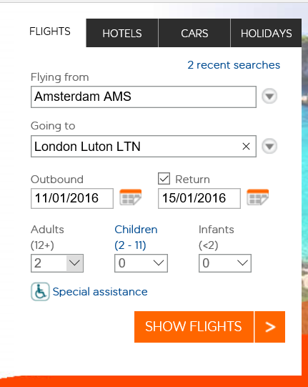

**You will find out what a return flight will cost to your chosen destination in the UK.**

* **You will fly from Amsterdam (AMS) to >your destination in the UK<**
* **Double check you have the correct dates**
* **The ticket is for two adults**
* **You have to book your flight from the Monday morning to the Friday afternoon**
* **Choose your best option**
* **Don’t forget to print screen!**

**Stap 3:**

**Ensure you write down all the details of the flight including showing your printscreen. Think about times, dates, prices, luggage and any additional things you might want to add.**

|  |
| --- |
| Details flights:  The plane flies away from the Netherlands at Monday October 17th at 08:40. The plane arrives at 08:50. It takes 1 hour and 10 minutes to fly to London from Amsterdam. You can take 20 kilograms of luggage with you per person.  When leaving London to go back to Amsterdam, the plane flies away at 20:10. The plane arrives at 22:20. It takes 1 hour and 10 minutes to fly to Amsterdam from London. You can take 20 kilograms of luggage with you per person.  We booked the flights from Amsterdam to London and from London to Amsterdam for two persons.  The price for two flights for two persons is €452,92. |

Assigment 1: Print Screen Flights

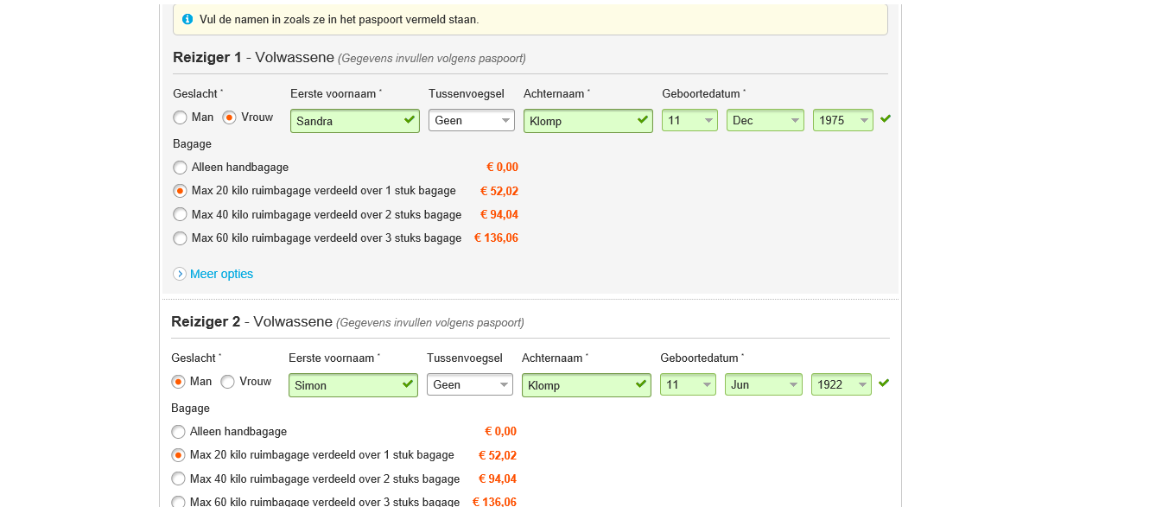Please paste your print screen of your flight information below

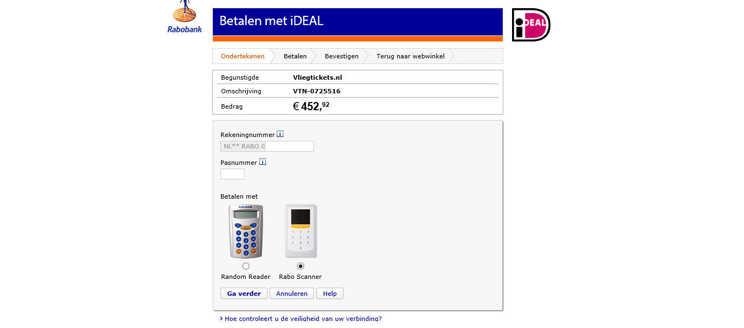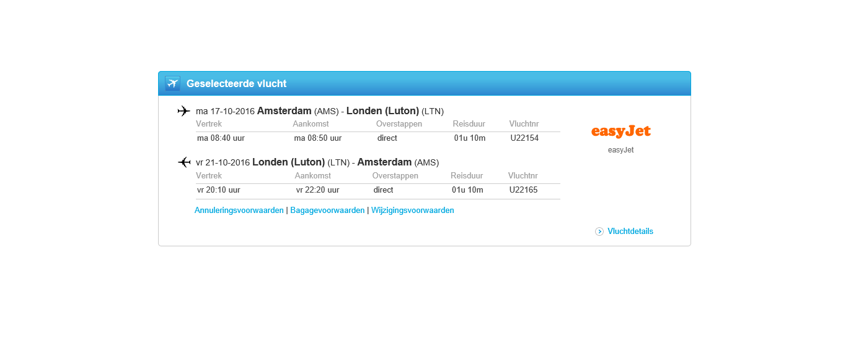Assignment 2: Book your stay

**Step 4:**

**In your previous assignment, you have chosen your flights to your destination. On top of going there, you will need a place to stay.**

**The minimum requirements are:**

* **It has to be one accommodation for the 4 nights you are there**
* **You need to include breakfast**
* **It has to be within your budget**
* **It has to have come from an English website**

**Tips for accommodation websites:**

* [**http://www.bedandbreakfasts-uk.co.uk/**](http://www.bedandbreakfasts-uk.co.uk/)
* [**http://www.bedandbreakfastnationwide.com/**](http://www.bedandbreakfastnationwide.com/)
* [**http://www.hotels.uk.com/**](http://www.hotels.uk.com/)
* **If you were to find another English website, that is allowed. Make sure you state your source!**

**Stap 5:**

* Write down the details of your accommodation, including dates, prices and facilities

|  |
| --- |
| Accommodation details:  We booked the stay from October 17th to October 21st. The hotel is called the Curzon House hotel. We booked for 2 persons. Breakfast included. The hotel lays in London. The price of the hotel is €472 for 4 nights.  You’ve got free wifi and a bathroom for yourself. |

Assignment 2: Accommodation

Please paste your print screen of your accommodation information below

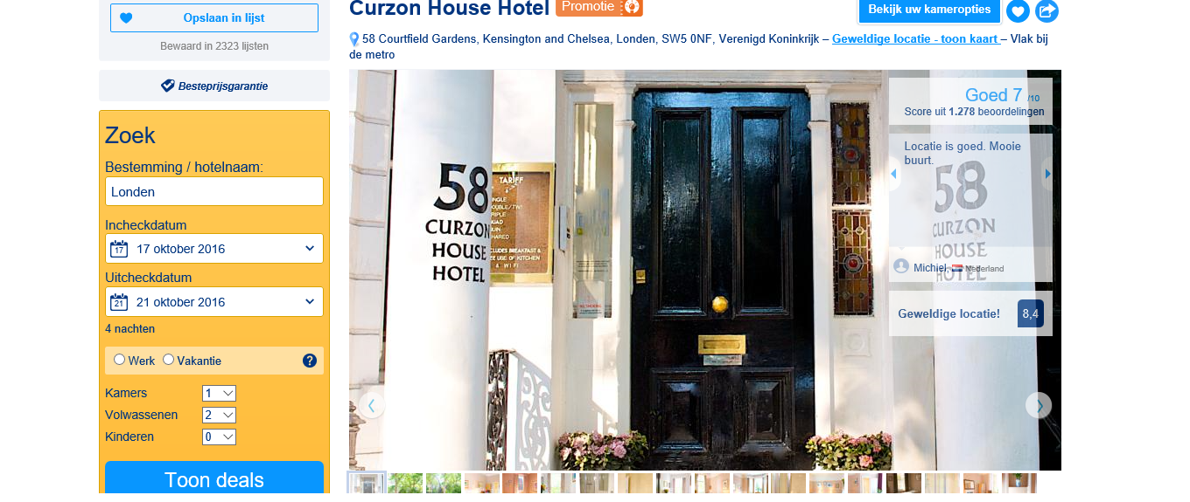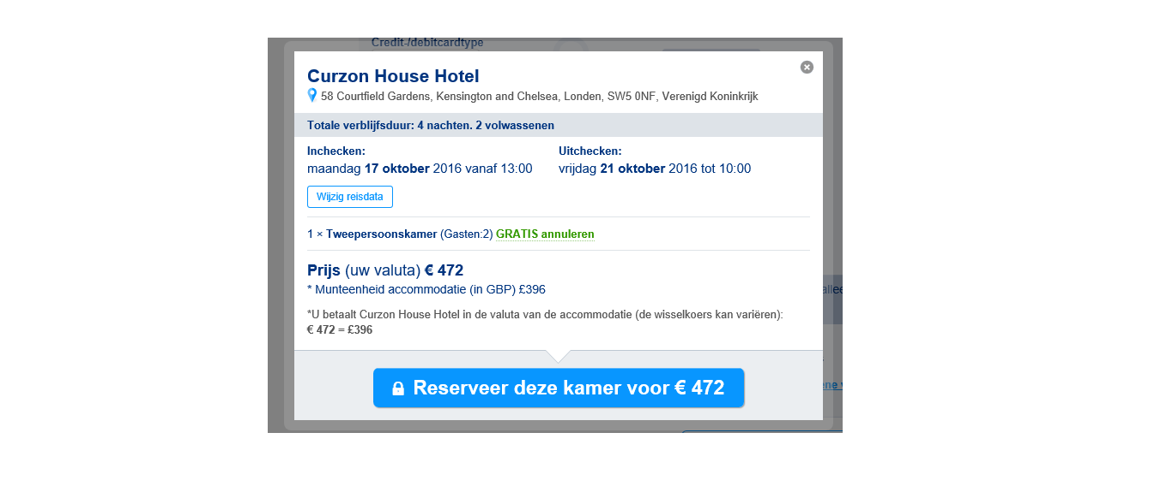

Assignment 3: What to do?

**Stap 6:**

You have booked your stay! Congratulations! However, you are a busy bee and would like to do something when you are there. After your arrival you will have to find a few activities. Please read below.

* **Day 1 (Monday):** your day of arrival. You will have a walk around your accommodation

and you will have to find a restaurant to eat at.

* **Day 2 (Tuesday):** visit to 1 activity
* **Day 3 (Wednesday):** visit to 1 activity
* **Day 4 (Thursday):** visit to 1 activity
* **Day 5 (Friday):** today is the end of your short break. See if you have any money and time left to do something.

**Please note!**

You are not allowed to visit the same activity twice!

**Activities could include:**

* Musea
* Events
* Gigs
* Theatre
* Anything the local ‘tourist office’ has to offer
* Any activity you would like to do whilst on holiday

**Be creative!**

|  |  |
| --- | --- |
| Day 1 | Activity: Dinner  Place: Berners Tavern, London  Description:  A good restaurant where you can eat. |
| Day 2 | Activity: The London Eye  Place: London  Description:  A big , spinning wheel where you can sit in and enjoy the sight you’ll have at the heart of London. |
| Day 3 | Activity: Madame Tussauds  Place: London  Description: A museum filled with waxed celebrity dolls. You can find a lot of famous “people” there. Like the queen, Selena Gomez, One Direction, and a lot more. |
| Day 4 | Activity: Concert Nickelback  Place: London O2 Arena  Description: A concert by Nickelback at the O2 Arena in London. Nickelback is a very famous band. The concert starts at 20:00. |

Assigment 3: Activities

Please paste your print screens of your activities information below

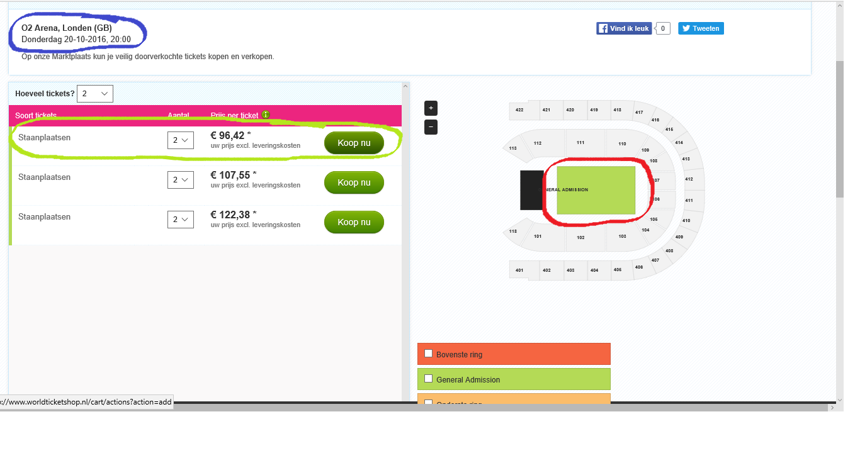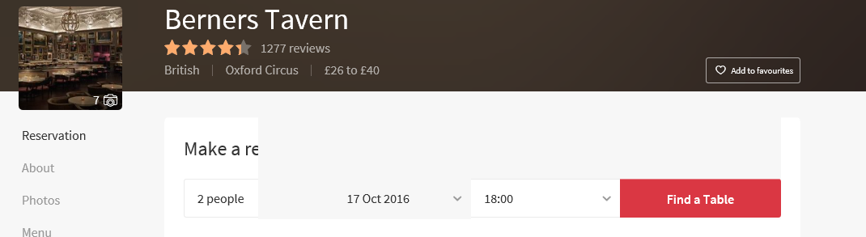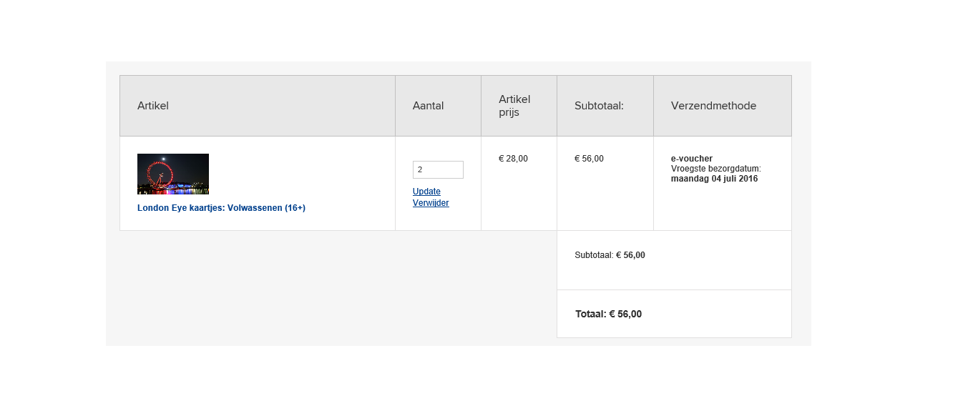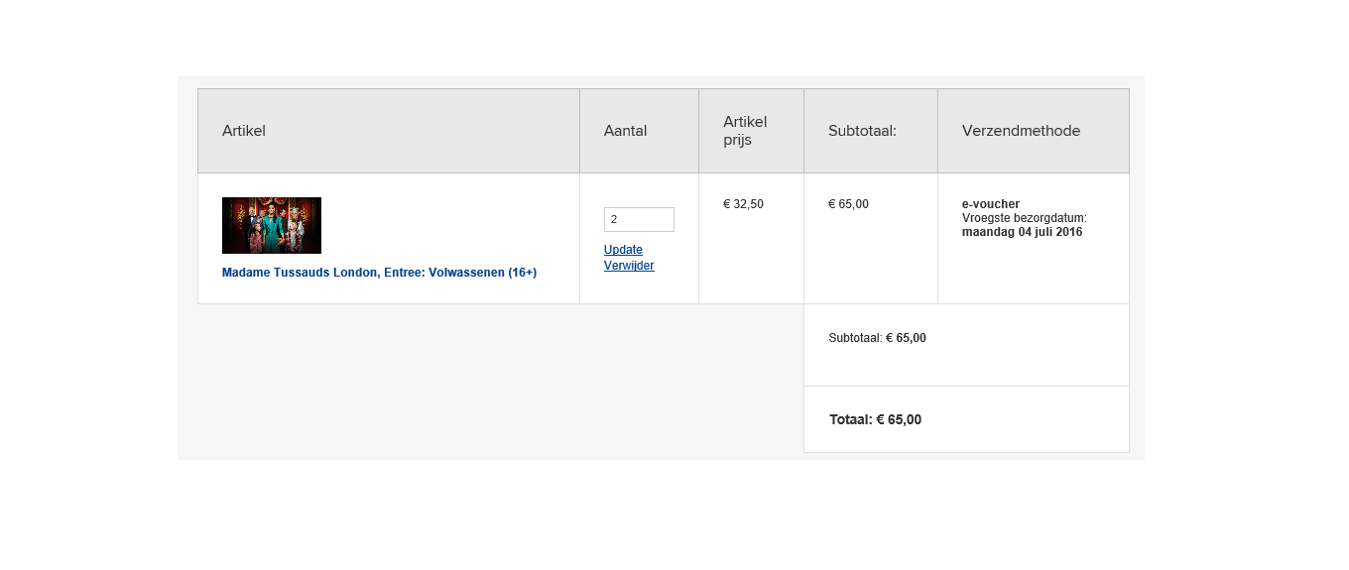

Assigment 4: Presentation

**Step 7:**

All of your information will now be gathered in a PowerPoint Presentation. Ensure it is a detailed description of your stay in the UK. And yes, it has to be in English.

Any questions, you know where to find me or email me via ELO/Magister.

Assignment 5: Personal Evaluation (pupil 1)

Name: Imara Dijk

Teacher: Mrs. Klomp  
Date: No, thanks.

The tasks I contributed were:

Booking the flight, booking two places for the Nickelback concert, booking the stay, finding the idea to visit the London Eye and Madame Tussauds, making the presentation and filling in this word document.

This is my opinion about the task and end result. Please explain.

The tasks weren’t that difficult, but it took a lot of time to make all of this. I really liked the idea of booking a holiday trip and it turned out really nice, I guess.

If you worked independent, please tell me what you found easy/hard/or what stood out for you.

If you worked together, please explain what you found easy/hard/or what stood out for you.

Finding a placet o go was really easy. We all thought London was a good idea. Finding activities was easy as well. But finding a place to stay was harder than I expected. All of the hotels we looked for were or really bad or really expensive.

Give yourself a grade on a scale from 1 to 10 about the full project.

Naam: Imara Dijk 1 2 3 4 5 6 7 **8** 9 10

What did you think about the project and what could improve it?

I think it was a nice project because I like planning vacations or some things like that. Although, we became a little pressed for time. So a few more Englisch lessions to work with the project would be really nice the next time.

Please grade the project assignments:

A trip to the UK! 1 2 3 4 5 6 7 8 **9** 10

Assignment 5: Personal Evaluation (pupil 2)

Name: Liza Te Wierik

Teacher: Mrs. Klomp

Date: 06/07/16

The tasks I contributed were:

I had tob ook a flight with a hotel. Also we had to find activities for a week to do for her and her husband.

This is my opinion about the task and end result. Please explain.

I found the job fun but also a bit difficult. You got a certain amount and you had to keep up. Everywhere was a night and so we thought it was for four days. Turned out not to be so and had it over again which was a bit stupid.

If you worked independent, please tell me what you found easy/hard/or what stood out for you.

If you worked together, please explain what you found easy/hard/or what stood out for you.

I thought it was nice that you could do it in pairs or threes. Otherwise i did present a bit exciting with it.

Give yourself a grade on a scale from 1 to 10 about the full project.

Naam: Liza Te Wierik 1 2 3 4 5 6 **7** 8 9 10

What did you think about the project and what could improve it?

The project I found very nice to do one time only was it a lot. And you had to do the course in Englisch what I thought already be difficult. Further I would like briefly just a little, as fewer days. I also liked it!!

Please grade the project assignments:

A trip to the UK! 1 2 3 4 5 6 **7** 8 9 10

Assignment 5: Personal Evaluation (pupil 3)

Name: Kaylin Steenwijk

Teacher: Mrs. Klomp

Date: 6/7/2016

The tasks I contributed were:

Searching for a flight.

This is my opinion about the task and end result. Please explain.

I think it’s a really good traveljourney it’s not to expensive.

If you worked independent, please tell me what you found easy/hard/or what stood out for you.

If you worked together, please explain what you found easy/hard/or what stood out for you.

Together, hard working togheter. I’m not that type of human.

Give yourself a grade on a scale from 1 to 10 about the full project.

Naam: Kaylin Steenwijk 1 2 3 4 5 **6 7** 8 9 10

What did you think about the project and what could improve it?

I would’ve done more than I did this time.

Please grade the project assignments:

A trip to the UK! 1 2 3 4 5 6 **7** 8 9 10